**The Basics**

**Major Characters**

These are the major characters in the Diablo II storyline, as outlined by the game’s designers from Blizzard North. This is not a detailed listing of each character’s motivations and personality, but rather, is merely meant to tell you a little about each character so you can identify where they ‘fall’ in the plot as you work your way through the game

Andariel

 Lesser Evil. Maiden of Anguish

Baal

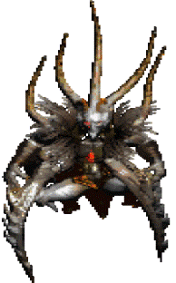The last of the Prime Evils. Brother of Diablo. Lord of Destruction

Diablo

Prime Evil. Lord of Terror

Duriel

Lesser Evil. Prince of Pain

Izual

Angel. Bore the rune blade “ Azure Wrath” in an assault on the Hell Forge and was corrupted. First gave the demons information about the soulstones. Now serves as a Lieutenant in Hell

Jered Cain

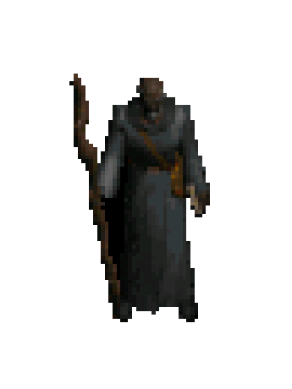Horadric Leader that pursued and captured Diablo

Mephisto

Prime Evil. Lord of Hatred

Tal Rasha

Tal Rasha was a powerful Horadric mage and leader of the Horadrim who sacrificed himself to forever encapsulate Baal in the dunes of Aranoch in the Tomb of Tal Rasha.

Tyrael

 He was the one who provided the Horadrim with the soulstones they used to imprison Diablo, Mephisto, and Baal with centuries before the time covered in Diablo and Diablo II, and he has appeared to humans in many other times and locations.